**Year 12 ATAR Chemistry**

Volumetric Analysis Investigation

NAME: ________________________ MARKS: _____ /28

**Instructions:**

* You will be given a mixture of sodium chloride and the diprotic malic acid (C4H6O5) powder.
* Using any reagents that you have made and standard titrating equipment, you must determine the mass of malic acid present in the sample. This value will be between 1.3-1.6 g.
* Your final answer must be stated to 3 decimal places.
* The code number/letter of your sample and your final answer must be written in the space provided at Question 9.
* You will have 60 minutes to perform the titration and 30 minutes to answer the following questions.

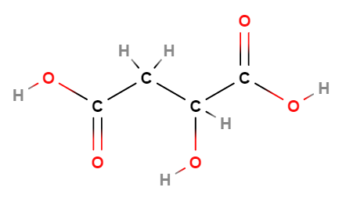

*2-hydroxybutanedioic acid (malic acid)*

**AIM**

What is the aim of this practical? [1 mark]

|  |
| --- |
|  |
|  |

**VARIABLES**

List two controlled variables for your titration method? [2 marks]

|  |
| --- |
|  |
|  |
|  |
|  |
|  |

**METHOD**

What is the absolute error associated with using the following pieces of scientific equipment?

[3 marks]

**Burette (final titre value)** **±** **mL**

**Pipette** **±** **mL**

List an additional two possible sources of error when performing a titration and label them as random or systemic? [2 marks]

|  |
| --- |
|  |
|  |
|  |
|  |
|  |
|  |
|  |
|  |

Complete the following details of your method:

* Size of volumetric flask used to make solution: ____________________
* Which solution did you put in the:

Conical flask ________________________

Burette ________________________

Complete the following table to indicate what effect the following steps would have on the calculated mass of malic acid. [3 marks]

|  |  |
| --- | --- |
| **Method** | **Effect on calculated mass of malic acid**  **[Write increase mass/decrease mass/no effect]** |
| Using water as a final wash before using the burette |  |
| Using water as a final wash before using the pipette |  |
| Using water to wash down drops of solution that had splashed up on the side of the conical flash before end-point was achieved |  |

Which indicator did you use in your titration? With the aid of suitable equations, explain your reasoning behind this choice as a suitable indicator. [4 marks]

|  |
| --- |
|  |
|  |
|  |
|  |
|  |

**RESULTS AND DISCUSSION**

Complete the following table for your titration. [3 marks]

Note: You DO NOT need to complete all the cells in the following table.

|  |  |  |  |  |  |  |
| --- | --- | --- | --- | --- | --- | --- |
|  | **Rough titration** | **Accurate titrations** | | | | |
| 1 | 2 | 3 | 4 | 5 |
| **Initial reading (mL)** |  |  |  |  |  |  |
| **Final reading (mL)** |  |  |  |  |  |  |
| **Titrate volume (mL)** |  |  |  |  |  |  |

Calculate the mass of malic acid in your sample (SHOW FULL WORKING). [5 marks]

|  |
| --- |
|  |
|  |
|  |
|  |
|  |
|  |
|  |
|  |
|  |
|  |
|  |

9. Complete the table below. [3 marks]

10. Calculate the percentage error of the average titre volume of your experiment. [2 marks]

Average titre volume = _________________

Percentage error =

|  |
| --- |
|  |
|  |
|  |
|  |
|  |

**End of Investigation**